

**Science and Sequencing Strategies of a Multi-Well Completion**

December 6. 2018

**Research project by**

**Ahad Momin (am82437)**

**Professor: Dr. Mukul Sharma**

**Table of Contents**

|  |  |
| --- | --- |
| Introduction | 3 |
| Zipper Fracturing Methodology | 3 |
| Stress Shadow Effect | 4 |
| Heterogeneity and Time-Dependent Stress Shadow | 7 |
| Fracture Sequencing and Strategies | 11 |
| Challenges of Zipper Fracturing | 14 |
| Modeling Strategy for Zipper Fractures | 15 |
| Conclusion | 15 |
| References | 16 |
|  |  |
| **List of Figures** |  |
| Figure 1a: Illustration of zipper fracture design vs sequential fracture design | 4 |
| Figure 1b: Staggered pattern zipper fracture design | 4 |
| Figure 2: Illustration of stress shadow around the fracture | 5 |
| Figure 3: The stress shadow effect in 2D (Nagel et al 2013) | 5 |
| Figure 4: Increase in Shmin vs stage spacing (Roussel et al. 2011) | 6 |
| Figure 5: Stress shadow field for zipper fractures (Roussel et al. 2011) | 7 |
| Figure 6: Microseismic picture and schematic of wells A,B,C and D | 8 |
| Figure 7: ISIP graphs for zippered (B & D) and non-zippered wells (A & C) (Manchanda et al. 2013) | 9 |
| Figure 8: Contour plot of IU fracture closure over time (Manchanda et al. 2014) | 10 |
| Figure 9a: Tip to tip fracture sequence | 11 |
| Figure 9b: Staggered double zipper sequence | 11 |
| Figure 10a: Triple zipper staggered fracture sequence | 11 |
| Figure 10b: Quadruple zipper staggered sequence | 11 |
| Figure 11: Lagging staggered triple zipper and lagging staggered double zipper (Patel et al. 2016) | 12 |
| Figure 12: Microseismic image of lagging staggered triple/double zipper (Patel et al. 2016) | 13 |
| Figure 13: Production rate vs months for double/triple zipper and lagging staggered double/triple zipper | 13 |
|  |  |
| **List of Tables** |  |
| Table 1: Data for well A, B, C, D (Manchanda et al. 2014) | 8 |

**Introduction**

In today’s era of unconventionals, the push for optimization and operational efficiency has helped the United States to improve its hydrocarbon production. Many of the oil and gas companies in the US utilize pad drilling and multi-well completions and invest millions of dollars to improve fracturing techniques for optimal hydrocarbon production. One of the multi-well fracturing techniques commonly used today is called zipper fracturing. From an operational perspective, zipper fracturing saves time and enhances production, but the science behind its success is quite complicated and unclear among the industry. Therefore, it is crucial to understand its methodology to make it more efficient.

In a multi-well completion, zipper fracturing refers to creating alternating fractures one stage at a time between two or more parallel wells in a zippered fashion. The technique reduces the necessary wireline (plug and perf) time cycles when compared to fracturing all stages in a well at a time, which is also known as sequential fracturing. The technique saves time and money, and creates a zipper-like structure, which increases rock stimulation, causing a tremendous increase in the wells’ initial production and recovery. However, in recent publications, many authors have conflicting opinions on the validity of zipper fracturing versus sequential fracturing in regards to production enhancement. Zipper fracturing has worked significantly well in the Eagle Ford shale and established dominance over other fracturing techniques. However, the reason for its effectiveness is poorly understood due to the complex fracture geometries and interactions caused by geological heterogeneity. In this research paper, the science behind operational success, studies of best current fracturing sequencing strategies, and prominent challenges of zipper fracturing will be discussed thoroughly.

**Zipper Fracturing Methodology**

Zipper fractures are applied in two or more parallel horizontal wells in perf and plug completion. The completions crew first prepares the stage to pump in one well using wireline (plug and perf) and then the wireline is moved to prepare stage to pump in a second well. The prepared stages are pumped and fractured while the wireline prepares another stage of the second well. This back and forth manner of fracturing saves operation time and money for companies when compared with sequential fracturing, where all stages are of the wells are fractured separately in a sequence. Figure 1a below shows the basic zipper design in two parallel wells.

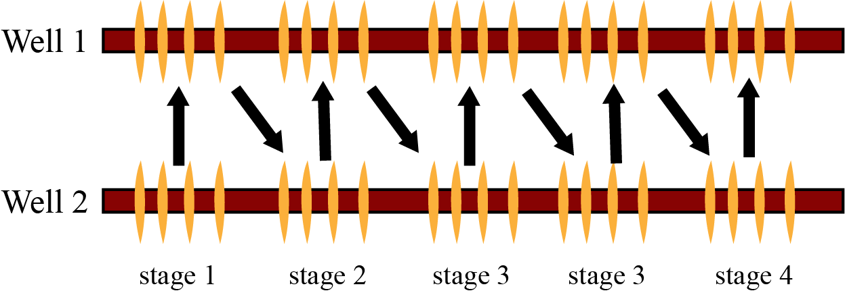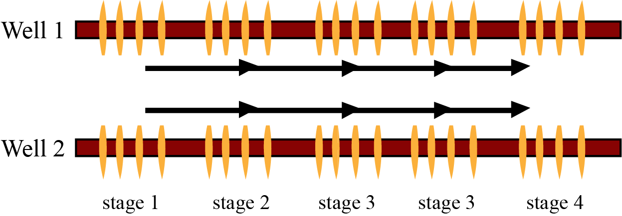

**Figure 1a: Illustration of zipper fracture design vs sequential fracture design**

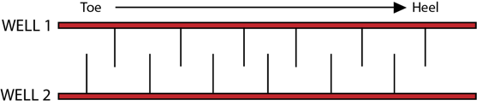

**Figure 1b: Staggered pattern zipper fracture design**

The key to achieving high fluid production is by creating high fracture complexity in the reservoir. This goal is often accomplished with extensive pad drilling and multi-well completions. Companies in the US are zippering three to four wells at the same time to achieve this goal. Different configurations and strategies in zipper fracturing design are studied to improve fracture design and recovery. The most common configurations are tip to tip (fig.1a) and staggered (fig. 1b). The tip to tip configuration describes a case where the fractures of both wells are placed opposite to each other. The staggered configuration describes a case where the fractures of the wells are purposely offset from nearby well’s fractures (Rafiee et al. 2012). The other configurations and innovative designs to zipper fracturing is studied in detail in the fracture sequencing and strategies section of this paper.

When understanding zipper fracturing, it is beneficial to understand its complex fracture mechanics, geometry and interactions. The two concepts of success behind this technique are the time dependent stress shadow effect due to induced unpropped (IU) fracture closure (Manchanda et al. 2014) and the presence of geological heterogeneity and natural fractures (Nagel et al. 2014). To understand these concepts, it is crucial to understand stress shadow, first.

**Stress Shadow Effect**

When a hydraulic fracture propagates, it reorients the stress field around the fracture and creates a stress shadow effect. The stress shadow affect has a great impact on the growth of subsequent fractures. The force at which the fracture in created induces a compression region perpendicular to the fracture and a tensile region at the fracture tip (Patel et al. 2016). The stress shadow affect is shown in the Figure 2 below.

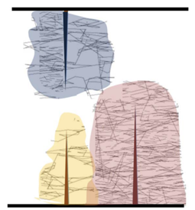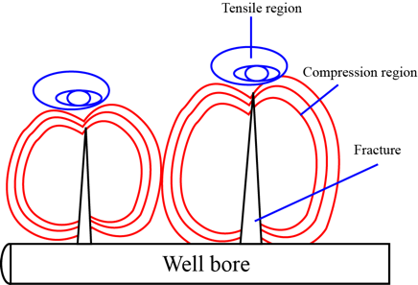

**Figure 2: Illustration of stress shadow around the fracture**

The force between two adjacent fractures attracts and affects the fracture growth of new fractures. The effects include deviated fractures from their orientation, screen outs, and uneven fracture geometry. Additionally, the natural fractures and fissures also govern the fracture geometry. The enhanced conductivity region established by these natural fractures causes new fractures to propagate in the direction of least resistant giving a biased fracture geometry (Nagel et al. 2014).

In many papers, it is stated that Young’s Modulus, fracture spacing, fracture geometry and in-situ stress are important parameter in fracture design and these parameters are affected by stress shadow. In the paper by Nagel and Sanchez (2013), it was noted that increasing horizontal minimum stress (Shmin) due to stress shadow extends distances more than 1000m behind a fracture and spreads out above and below. The Shmin increases if the spacing of the stages are reduced. In another 2018 publication, Nagel did continuum simulations to understand the stress shadow behavior (Nagel et al 2013). To obtain a single hydraulic fracture stress shadow a series of initial simulations were conducted to understand the impact of fracture height and stage spacing. Figure 3 shows the stress shadow obtained from a single hydraulic fracture and its effect on Shmin when the height is increased from, 40 to 80 m.

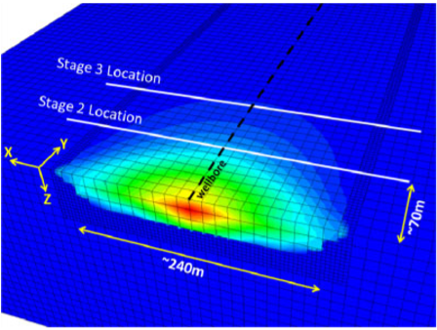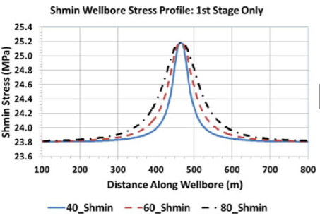

**Figure 3: The stress shadow effect in 2D (Nagel et al 2013)**

In his conclusion, the stress shadow greatly affects Shmin, and the effect from a single fracture is strongly controlled by the fracture height and stage spacing.

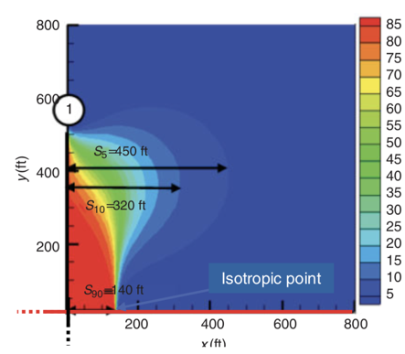The stress shadow not only contributed by mechanical effects as discussed above but also by poroelastic effects. The first poroelastic effect is seen from the depletion of reservoir. As the pore pressure decreases in the reservoir, the in-situ stress changes. The second poroelastic effect is seen when the pore pressure gradients are different. The gradient changes the stress orientation of the fracture. However, these poroelastic effects are negligible during fracking of new wells in a new location, but they plays important when refracturing an old well. Notable work has been done on stress shadow by Roussel and Dr. Sharma (Roussel et al. 2011). The authors has quantified the stress field in horizontal plane with displacement continuity methods for multiple transverse fractures. The model was built by solving algebraic system of 15 equations for 15 unknowns (six components of stress and strain plus the three components of the velocity vector) (Roussel et al. 2011). Figure 4 shows the simulation ran by Roussel in 2011 to show the stress reorientation due to mechanical effects. It was assumed that the rock is homogenous; Nevertheless, when there is heterogeneity such as natural fractures, the stress distribution is different.

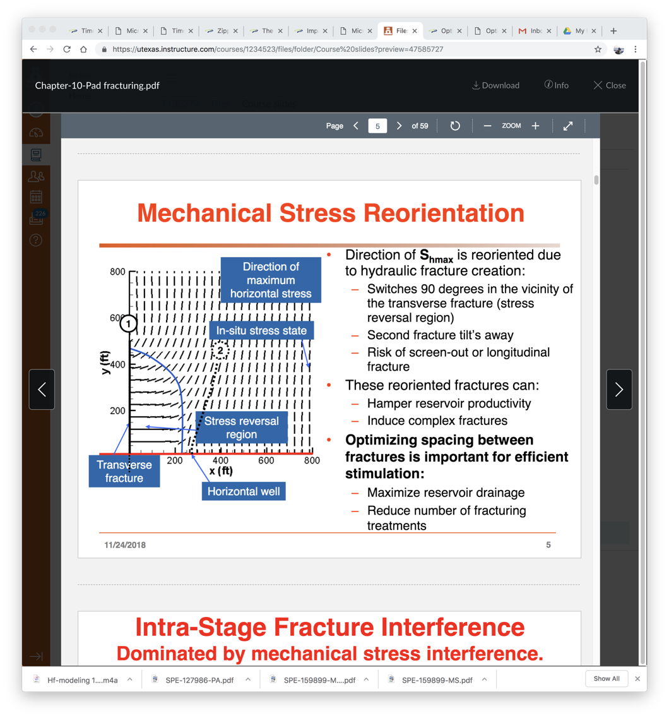

**Figure 4: Increase in Shmin vs stage spacing (Roussel et al. 2011)**

The point 1 pictured in Figure 4 is the first fracture in the horizontal well and point 2 is the second fracture. The dotted lines are the horizontal maximum stress (Shmax). The Shmax stress is flipped as Shmin is increased. Due to the reversal, the second fracture deviates and causes screen out. This determines how the fractures will propagate and thus becomes necessary in fracture spacing and stage sequencing in multi-well completion. Figure 5 shows the stress field in zipper fractures (Roussel et al. 2011) and it can be clearly seen that the stress shadow fields are highly dependent on fracture spacing.

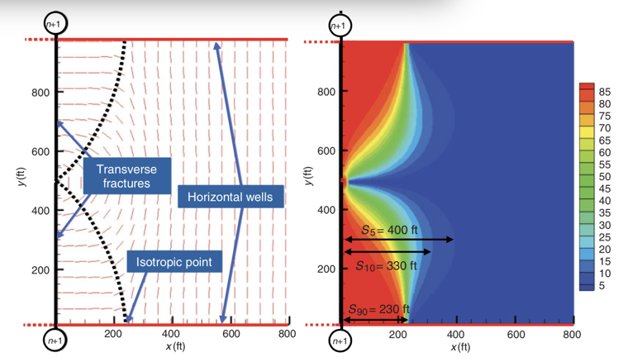

**Figure 5: Stress shadow field for zipper fractures (Roussel et al. 2011)**

**Heterogeneity and Time-Dependent Stress Shadow**

It is imperative to not neglect that the stress shadow is time dependent. In zipper fracturing the time variable of stress shadow is the core reason why it works well. This is described fully in previous works by Dr. Sharma and Manchanda (Manchanda et al. 2014). When the treatment is pumped, both propped and induced unpropped (IU) fractures network are fully open. Overtime, the unpropped fractures close due to fluid leak off, which the reduces the fracture width. This significantly reduces the stress shadow and fracture interference leading to improved fracture performance (Manchanda et al. 2013). These IU fractures allows fractures from later stages to propagate into its open conductivity due to stress reorientation. This fracture interaction can lead to wastage of proppant and capital as the region that is being stimulated has already stimulated by the previous stage (Manchanda et al. 2014). So, over time these IU closures make an efficient fracture geometry. The previous works by Manchanda (Manchanda et al. 2012) showed that the fracture creates more complexity in low stress regions, and as the stress is decreased by IU closure, the fracture performance increases.

If there is a fairly high stress contrast, the fracture trajectories will be smooth and vice versa. The idea can be postulated that if the stress shadow is not flipping the direction of fractures then as the stage number increases from toe to hill, the instantaneous shut in pressure (ISIP) increases. If the fractures are running into each other the ISIP has a large disparity.

Manchanda and Dr. Sharma did a study on four wells, A, B, C and D. Wells A and C were sequentially fractured, and wells B and D were zippered as seen in Figure 6. The data is shown in Table 1.

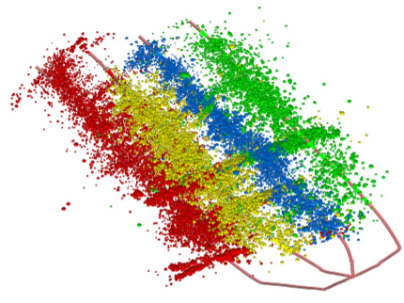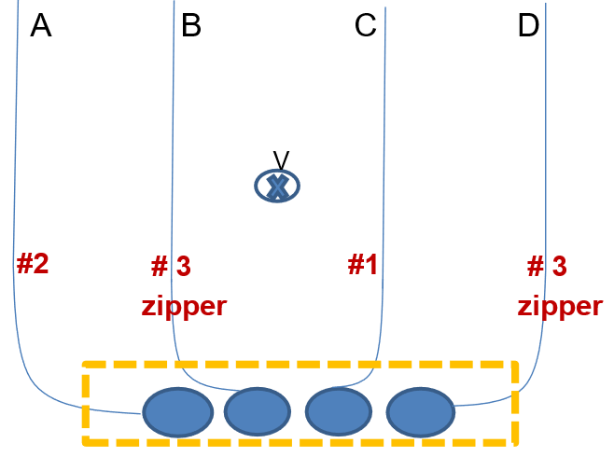

**Figure 6: Microseismic picture and schematic of wells A, B, C and D (Manchanda et al. 2014)**

**Table 1: Data for well A, B, C, D (Manchanda et al. 2014)**

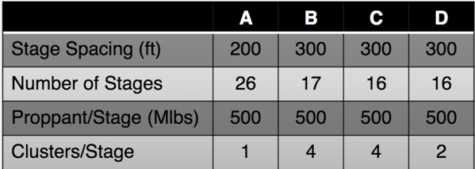

The production of wells B and D was better than A and C. To find the reason behind B and D’s high production, data was collected using microseismic, pressures, and tracers. The microseismic data events showed overlap between adjacent stages in sequentially fractured wells but does not overlap significantly between adjacent stages in zipper fractured wells. This indicated that there is more fracture interference between sequentially fractured wells. The instantaneous shut in pressure (ISIP) graph versus stage number was plotted. Figure 7 shows the graphs obtained. As seen in the graphs, wells B and D showed less ISIP fluctuation where as, well A and C showed more. It was then concluded that the zippered wells have low fracture interference versus the non-zippered wells.

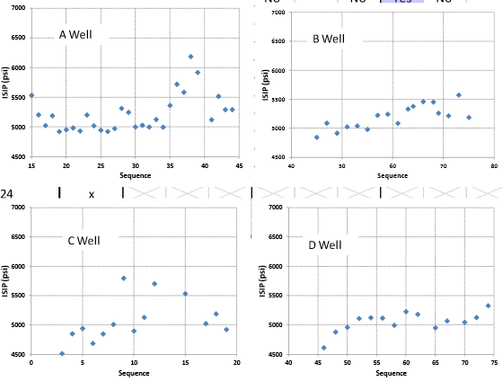

**Figure 7: ISIP graphs for zippered (B & D) and non-zippered wells (A & C)** (**Manchanda et al. 2013)**

To answer the question of why there are more ISIP spikes seen in wells A and C, the authors used a model and ran simulations to see mechanical and poroelastic effects. Neither the mechanical or poroelastic effects were sufficient enough to explain the inter-well interference. Further study was conducted by Dr. Sharma and Manchanda and it was noted that the time between these fractures of a sequentially fractured well is generally on the order of 3 to 4 hours, while in zipper fractured wells, the time between consecutive fractures in the same well increases to approximately 6 to 7 hours. Therefore, when the time is doubled, the IU fractures have more time to close as the fluid leaks off. The analytical expression given by Eq.1 and Eq.2 was derived to describe the change in stress interference caused by fracture closure, where is the net pressure as the crack is opened andis the half-length.

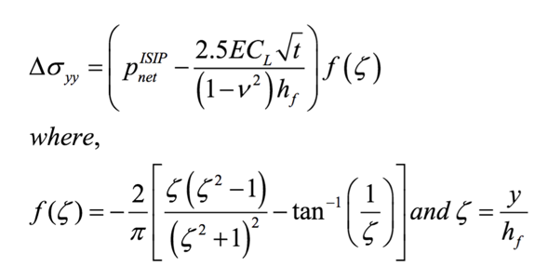

Eq.1

Eq.2

Contour plots of IU fracture closure with time were generated as shown in Figure 8. The contours demonstrated how the IU fracture closing decreases the stress shadow up to 500 psi, which is enough to reduce fracture interference.

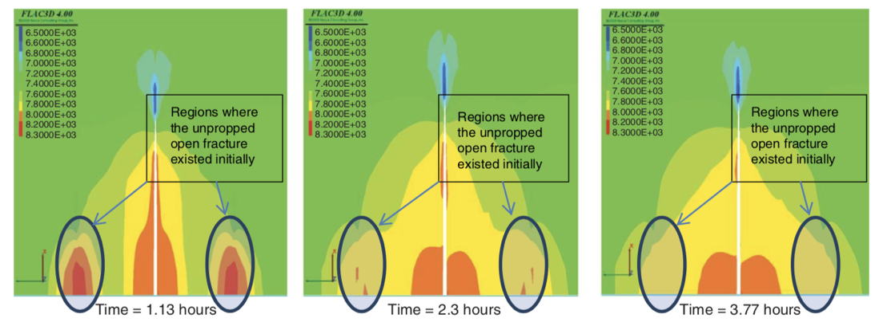

**Figure 8: Contour plot of IU fracture closure over time** (**Manchanda et al. 2014)**

The hypothesis was built that the time between two adjacent fracture stages in a single well should be maximized without compromising the rig time. The complete study of time dependent stress shadow and fracture interference can be found in papers by Manchanda (Manchanda et al. 2014 & Manchanda et al. 2013).

By examining these studies, it can be said that the time dependency of stress shadow due to IU fracture closure explains why zipper fracturing works. It is also important to know that these unpropped fractures are induced due to geological heterogeneity and the presence of natural fractures. The natural fractures enhance the zipper operation as more unpropped fractures are opened. There have been conflicting studies where sequential fracturing has worked better than the zipper fracturing. One possible reason for this is the complexity of natural fractures. The natural fractures’ characteristics such as orientations affects the IU fractures and ultimately the stress shadow system in hydraulic fractures. It is also thought that the zipper fracturing stabilizes the natural fractures and affects the fracture performance. The study on this natural fracture stabilization can be found in SPE literature (Nagel et al. 2014).

With this understanding that the stress shadow phenomena is controlled by fracture height, fracture width, stage spacing, and heterogeneity and most importantly time, doors open to show how zipper fracture enhances production and how different configurations can make the technique more efficient.

**Fracture Sequencing and Strategies**

Like mentioned above, the zipper fracturing sequencing and strategies can be improved to create more complex fracture networks if enough time is given between fractures. Two or more wells can be zippered, but it is always better to do three or four to increase time between adjacent fractures of each well. The staggered fashion is used in all sequencing because it stimulates more of the reservoir rock. The strategies mentioned below are adopted from the works of Manchanda and Patel (Manchanda et al. 2013 & Patel et al. 2016).

**Zipper Fracturing Strategies**

Double Zipper

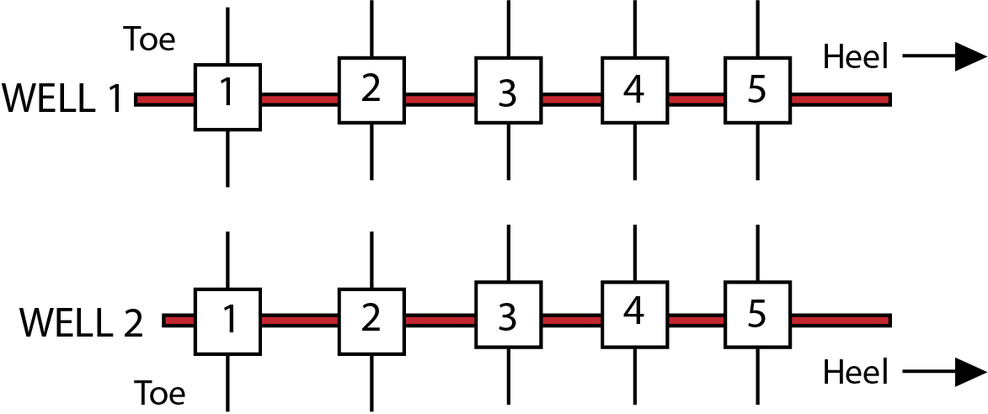 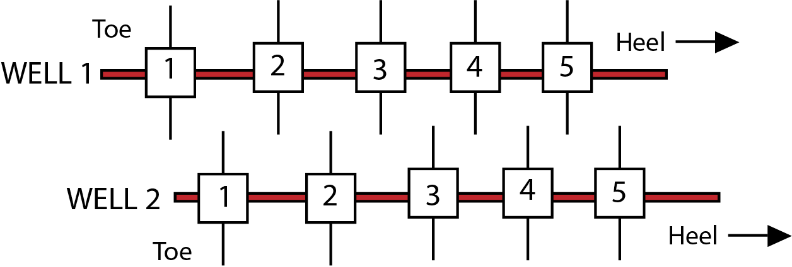

**Figure 9a. Tip to tip fracture sequence b. Staggered double zipper sequence**

Pictured above in Figure 9a and 9b are the zipper fracturing configurations for two parallel wells. The numbers in the squares shows the sequence at which the stages are fractured. By alternating stages, the rig time is saved and the time between adjacent fractures of the same well are increased. This additional time increases the fracture efficiency and stimulates more rock. Moreover, the staggered pattern increases the volume of the fractured reservoir.

Triple and Quadruple zipper

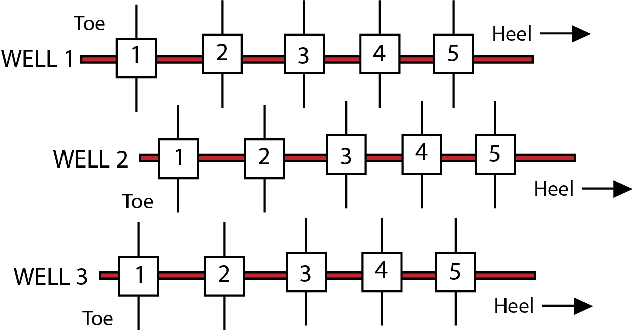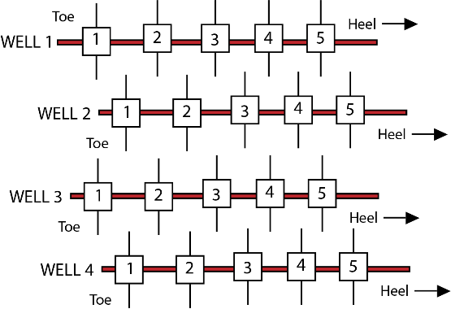

**Figure 10a. Triple zipper staggered fracture sequence b. Quadruple zipper staggered sequence**

In Fig 10a the triple zipper configuration is shown and in Fig 10b the quadruple zipper configuration is shown. By zippering three and four wells, the delay time between adjacent fractures of each well is increased even more, which causes less fracture interference and ultimately better production.

To increase more efficiency and fracture performance, the lagging staggered double zipper and lagging staggered triple zipper fracture sequence are executed today. Figure 11 shows lagging staggered triple zipper and lagging staggered double zipper. The number shows the sequence in which the stages are fractured.

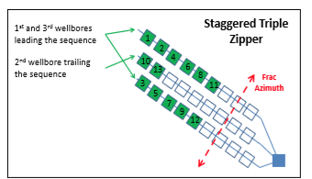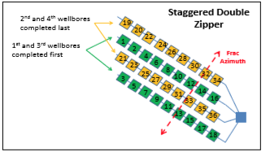**Figure 11: Lagging staggered triple zipper and lagging staggered double zipper (Patel et al. 2016).**

Lagging Staggered Double zipper

Lagging Staggered Triple zipper

In lagging staggered triple zipper configuration, the first two wells on the right and left side of the wells are zippered first for a few stages and then the middle well is zippered, which lags the sequence. This creates a lot of time for adjacent fractures in all three wells. In the lagging staggered double zipper configuration, four wells are completed. The two non-directly offset wells are zippered first followed by the two other non-direct offset wells, which lags behinds the sequence. This lagging staggered double zipper gives extensive amount of time to the fracture and gives low fracture interference for better results.

The field trial was performed in the lower Eagle Ford shale (Patel et al. 2016) to see which strategy works well. The well spacing and other parameters were kept consistent. In triple and double zippers configuration, greater fracture interference was seen through micro seismic and tracer data, while in lagging staggered triple/double zipper, the fracture growth was seen more uniform. Figure 12 shows the microseismic image of lagging staggered triple/double zipper. It was observed immediately that the fracture interference was quite low.

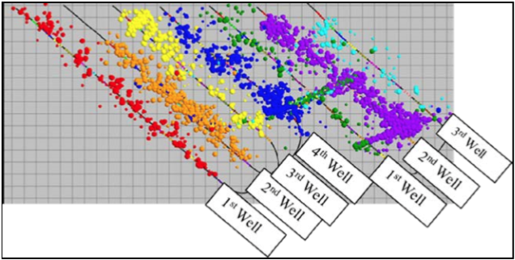

**Figure 12: Microseismic image of lagging staggered triple/double zipper (Patel et al. 2016).**

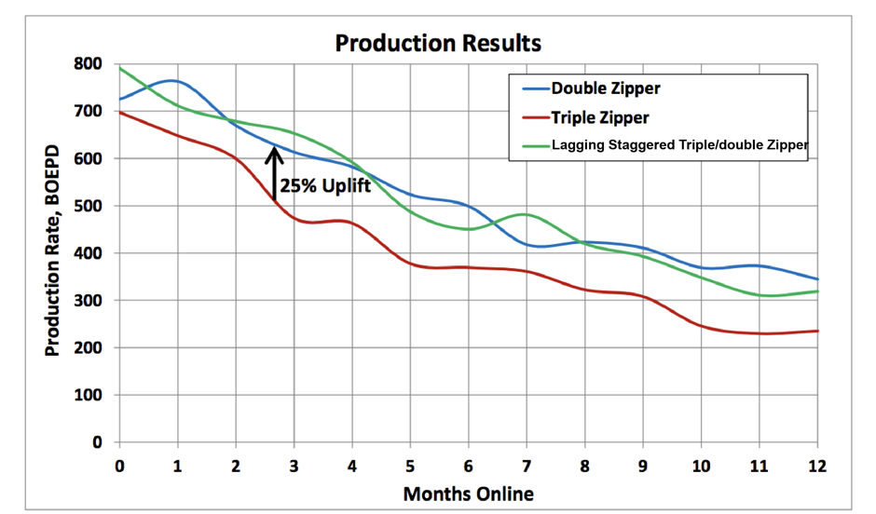The production data was analyzed in (Patel et al. 2016). As seen in Figure 13, the production of lagging staggered double/triple zipper showed better production than normal triple and double-zippered wells.

**Figure 13: Production rate vs months for double/triple zipper and lagging staggered double/triple zipper**

Overall, the results displayed above are substantial. These results give the industry a chance to test more techniques and come up with more innovations and improved strategies to enhanced hydrocarbon production. Furthermore, it shows that the operational efficiency can be maximized by using lagging staggered sequences on large multi-well pads without sacrificing production performance and rig time. Understanding the science behind the success of zipper fracturing has genuinely helped the industry to develop more efficient strategies. However, there are many complexities and challenges of this fracturing technique, and, therefore, detailed investigations of zipper fracturing are still needed to be conducted to make this more operationally efficient.

**Challenges of Zipper Fracturing**

Challenges rise in many areas of zipper fracturing. Operationally, it is quite tough to fracture three to four wells at the same time, as it requires more capital in both drilling and completions. Geological heterogeneity also becomes a big problem when modeling and understanding physics behind the process. Companies are zippering three to four wells, and it is a big change for fracing crews. The crew is constantly moving between wells, as they do not have dead time between stages anymore. There is huge capital involved in zipper fracturing, which many companies choose not to spend. It is also important to note that sand/proppant is ready at the pad, and due to high transport problems, there are many challenges to get the right amount of sand on the field. As previously discussed, time is important in zipper fracturing, but time efficiency is hard to achieve with such large frac jobs. Furthermore, when executing zipper fractures, constant high-horsepower pumps are required. “The constant rate of high-horsepower pumping has a downside for service companies; their pumping trucks are lasting about half as long when working on zipper fractures” (Jacob, T 2014). Maintenance is required between every frac job, and with zipper fracturing there is almost not enough time to complete the necessary maintenance. Numerous pieces of equipment are moving in on a pad, and it can be chaotic if there is no plan or sequence. Despite these challenges, companies today have successfully run many trials and showed great operational efficiency in the process.

Since zipper fractures today work case by case due to geological heterogeneity, it makes it harder to decide which zipper sequencing will work better. Specific well patterns, orientations, and completion types should be taken into account when designing zipper strategies (Patel et al. 2016). In many zipper fracs, the fracture discontinuities are common due to faults, fissures and natural fracs. Therefore, geological heterogeneity is something that is needed to be studied and developed more to further optimize the technique. Dr. Sharma and his research team at UT Austin has developed many models to improve strategies case by case. Operational software is now available at UT which can model more than 100 fracturing stages in a multi-well pad (Jacobs, T 2014).

**Modeling Strategy for Zipper Fractures**

It is very challenging to make a perfect model for zipper fracture, monitor the stress interferences and fracture growth. The technique taught by Manchanda in his paper (Manchanda et al. 2018) to 3D model the fracture geometry by analyzing the pressure interference between fractured horizontal wells can be used to model zipper fractures. The pressure is measured in the monitor well when the offset well is fractured. The model captures the impact of a propagating hydraulic fracture on the pressure response observed in a fractured monitor well. When treating each stage in the zipper sequence, the pressure response can be measured. The propagating fracture creates a pressure difference in the monitor by squeezing the fluid in the fracture of the monitor well. The detailed study of the model can be found in the paper mentioned above.

**Conclusion**

With moving technology in multi-well completion, industry is moving more towards the optimization and operational efficiency. Zipper fracturing has recently been a big success in the industry but the science behind its success is poorly understood. The zipper fracturing technique can be optimized if a proper understanding can be obtained. The stress shadow plays important role in understanding the zipper fracturing technique. Stress shadow is controlled by spacing, fracture height, fracture width, and most importantly, time. The reasons for its success is the time-dependent stress shadow due to closure of IU fractures, as the fluids leaks off overtime. The IU fractures are usually developed due to heterogeneity (natural fractures, fissures, faults) in the formation. The studies presented above have shown that IU fractures reduces the stress shadow when they close, which reduces the fracture interactions between the adjacent stages of each well. The sequencing strategies are developed based on this important phenomenon. The strategies used today are double, triple, and quadruple zipper and lagging staggered double and triple zippers. The field tests have shown that the lagging staggered double and triple zipper show better production than just the double and triple zipper. Major challenges and limitation that zipper fracturing faces today is the need for high-horsepower pumps, huge capital, and maintenance. Fracture discontinuities are still a major problem when understanding this technique, and, therefore, geological heterogeneity needs to be studied and developed more to further optimize the technique. The fast growing research and studies have shown innovative designs, and at this pace, I believe the efficiency of this technique will increase significantly in future.

**References**

Jacobs, T. (2014, October 1). The Shale Evolution: Zipper Fracture Takes Hold. Society of Petroleum Engineers. doi:10.2118/1014-0060-JPT

Manchanda, R., & Sharma, M. M. (2013, September 30). Time-Delayed Fracturing: A New Strategy in Multi-Stage, Multi-Well Pad Fracturing. Society of Petroleum Engineers. doi:10.2118/166489-MS

|  |
| --- |
| Manchanda, R., Sharma, M. M., & Holzhauser, S. (2014, November 1). Time-Dependent Fracture-Interference Effects in Pad Wells. Society of Petroleum Engineers. doi:10.2118/164534-PA |

Nagel, N., Sheibani, F., Lee, B., Agharazi, A., & Zhang, F. (2014, February 4). Fully-Coupled Numerical Evaluations of Multiwell Completion Schemes: The Critical Role of In-Situ Pressure Changes and Well Configuration. Society of Petroleum Engineers. doi:10.2118/168581-MS

Nagel, N. B., Zhang, F., Sanchez-Nagel, M. A., & Lee, B. (2013, January 1). Evaluation of Stress Changes Due to Multi-Stage Hydraulic Fracturing – Consideration of Field Results. International Society for Rock Mechanics and Rock Engineering.

Nagel, N. B., & Sanchez-Nagel, M. (2011, January 1). Stress Shadowing and Microseismic Events: A Numerical Evaluation. Society of Petroleum Engineers. doi:10.2118/147363-MS

Rafiee, M., Soliman, M. Y., & Pirayesh, E. (2012, January 1). Hydraulic Fracturing Design and Optimization: A Modification to Zipper Frac. Society of Petroleum Engineers. doi:10.2118/159786-MS

Roussel, N. P., & Sharma, M. M. (2011, May 1). Optimizing Fracture Spacing and Sequencing in Horizontal-Well Fracturing. Society of Petroleum Engineers. doi:10.2118/127986-PA

Patel, H., Cadwallader, S., & Wampler, J. (2016, August 1). Zipper Fracturing: Taking Theory to Reality in the Eagle Ford Shale. Unconventional Resources Technology Conference. doi:10.15530/URTEC-2016-2445923

Seth, P., Manchanda, R., Kumar, A., & Sharma, M. (2018, September 17). Estimating Hydraulic Fracture Geometry by Analyzing the Pressure Interference Between Fractured Horizontal Wells. Society of Petroleum Engineers. doi:10.2118/191492-MS